**RR Interval ( Probably the value is in Milliseconds)**

**RR interval**, the time elapsed between two successive R-waves of the QRS signal on the electrocardiogram (and its reciprocal, the HR) is a function of intrinsic properties of the sinus node as well as autonomic influences.

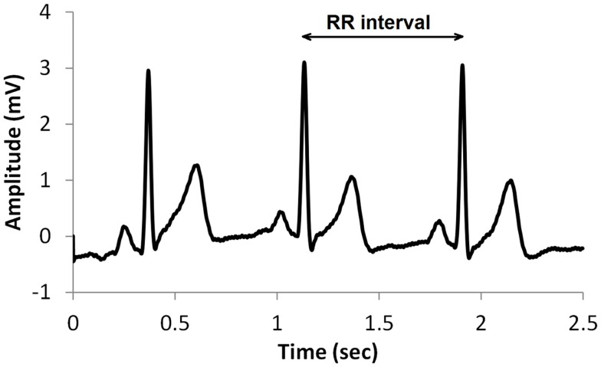

The instantaneous heart rate is measured as the time in seconds between peaks of two consecutive R waves of the ECG signal. This time is referred to as RRI. The frequency spectrum of the RRI data is divided into three main bands: VLF (0.0033-0.04 Hz), LF (0.04-0.15 Hz), and HF (0.15-0.4 Hz).

**The datasets contains information directly or indirectly related to RR.**

Like SD1 and SD2 in second file.

The Poincaré plot is a scattergram, which is constructed by plotting each RR interval against the previous one. The Poincaré plot may be analyzed quantitatively by fitting an ellipse to the plotted shape. The center of the ellipse is determined by the average RR interval [5]. SD1means the standard deviation of Poincaré plot perpendicular to the line-of-identity, while SD2 represents the standard deviation of the Poincaré plot along the line-of-identity

https://www.researchgate.net/figure/The-Poincare-plot-SD1-and-SD2-standard-deviations-of-the-scattergram_fig1_290416554